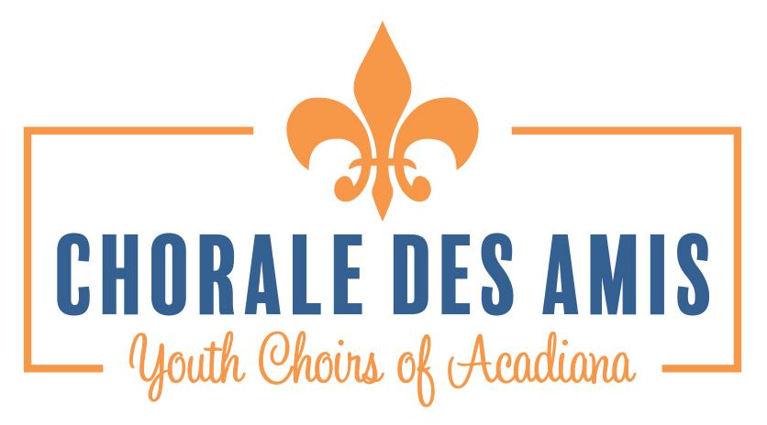

Student Name: ____________________________________ Date of Birth: ____ - ____ - _____

Student Address: ________________________________City____________________ Zip________

Grade for 2019-2020: _______ School: _________________________________

Siblings in Chorale des Amis ____________________________________________

REGISTRATION INCLUDES 1 SHIRT FOR THE MEMBER. IT IS A COLLARED, POLO SHIRT

Shirt size: YS YM YL AS AM AL AXL AXXL-($3 CHG) CIRCLE ONE

Mother’s Information:
Name:
Home Phone:
Cell Phone
Work Phone

Other Emergency Contact

Relationship
Name:
Home Phone:
Cell Phone
Work Phone

Father’s Information:
Name:
Home Phone (if different):
Cell Phone
Work Phone

Other Emergency Contact

Relationship
Name:
Home Phone:
Cell Phone
Work Phone

Family Physician Phone

Chorale des Amis Annual Financial Agreement

- Students are charged $500 annually to help fund the expenses of Chorale.
- Membership is for one full season, August through March 1 and through May for small groups and Petits.
- Each singer is expected to remain active and committed for the entire season.

A $45 registration fee is due upon registration of each member of Chorale des Amis and includes a shirt for informal performances. Registration fee due as soon as student is accepted

Additional Fees
- Uniforms are approximately $100 for girls and $120 for young men. We are using the same attire from last year. Some dresses are available for re-sale. Contact the CDA offices to see if one might fit your student
- ACDA All-State audition and participation fees (optional). Open to rising 4th grade-12th grade students
- Touring Fees: specific to each tour (optional)

Monthly Fee Charges:

PETITS: 10 months @$50 per month
CHANTEURS/LA CHORALE: 10 month program: $50 per month
CHANTEURS/LA CHORALE: 7-month program: $200 due Aug. 1; $50 per month Sept-February

Tuition Payment Plans (please select your payment option):

Full annual tuition paid by August 1, 2019 5% discount
Two (2) payments auto drafted August 1 and Sept. 1, 2019 3% discount
Families who enroll 3 or more children 50% discount on the 3rd child
Monthly- 1st payment is $200 due August 1 $50 monthly
*6 monthly payments of $50 auto drafted on the 1st of each month PLEASE NOTE: ALL CREDIT CARD PAYMENTS MADE TO CHORALE DES AMIS WILL INCUR A FEE TO COVER THE COST OF THE CARD

Name on Card (Please PRINT) :
Credit Card Number: ______________________________ Expiration ____________
Security Code __________ Billing Zip __________

Responsible Parent / Guardian Signature (must match name on card)
I agree to recurring monthly payments to be deducted to Chorale des Amis for tuition payments

Tuition Assistance:
Applications may be obtained by emailing choraledesamis@gmail.com. Please be in communication with the Executive Director, Ellen McLemore, about how we can best help you. Any family requesting assistance will be asked to pay a minimum amount (starting at $10 monthly) based on need and ability to pay. There will be no full-tuition scholarships given.

Registration and Commitment

The choirs may be called upon by community members, churches and civic clubs to perform for various events. Within reason, the choir will make an effort to accommodate these requests. Therefore, in accepting a position in this choir, students are obligated to (please initial each):

- _____ Perform a diverse repertoire of music including sacred and patriotic songs
- _____ Be agreeable to performing inside a church of any denomination
- _____ Participate in the following among other opportunities to perform:
- Summer Retreat July 29-Aug 1
- Christmas Dress Rehearsal and Concert December 8-9
- Christmas Rehearsal and Concert with ASO December 18-19
d. Spring Rehearsal and Concert, Feb. 29-March 1, 2020
4. _____ Available for some performances that may be requested by community groups
5. _____ Agree to be a reliable member for the entire season (August 2019-March 1, 2020)
6. _____ If not paid in full at the beginning of the season I agree to payment through recurring monthly payments by credit card. I understand that should my child not finish the season FOR ANY REASON, I must pay the outstanding balance on my account. The payment must be paid immediately, upon leaving Chorale.

My non-refundable $45 Registration Fee (represents my acceptance into the CDA Choral Program for the 2019-2020 season).

MEDICAL

Allergies / Reaction / Treatment

Daily Medication / Dispensing Instructions / Time(s)

OCT Medications that you give permission for your child to receive and/or administer themselves, for minor discomfort / reactions: (circle all that apply)

Benadryl Tylenol Advil Alleve Cough drops Sudafed Immitrole

Pepto Bismol Imodium AD Other________________________________________

Child’s vaccinations are up to date: Yes No
Child’s most recent tetanus vaccination (Year)
Child wears (check all that apply): Glasses Contacts
Child is epileptic or prone to seizures: Yes No
If YES, advise medication and treatment for possible seizure:

Note: CDA directors must know about any medications (including OTC) students are allowed to have in their possession and how it is to be dispensed (on chart above). All medication is to be in the original container. Please indicate any special medical conditions or additional statements affecting your child. Describe in detail the nature and severity of any physical and/or psychological ailment, illness, propensity, weakness, limitation, handicap, disability, or condition to which your child is subject and of which the sponsors should be aware, and what, if any, action or protection is required on account thereof. Attach this information with the form, if necessary.

Public Release

Documented parental permission is required in order to print a student name on a choir program or a choir special event t-shirt, release printed or video of group shots of students electronically, or in any way publicize student names/ pictures or to release personal student information (i.e. name, grade level, choir membership, awards etc.) in association with CDA Choir activities.

This requirement does not apply to students who are 18 years or older or to students who are emancipated.

***I do not consent to my child’s information/image being used in conjunction with Chorale

Parent Signature

CONSENT

I hereby give consent to the following as explained above:

- CDA DIRECTORS and chaperones to administer medication or seek emergency medical/surgical treatment for my child. I realize I am liable for any medical costs incurred. I have provided a copy of my insurance card.

- The public release of my child’s NAME, PHOTOGRAPH, AGE & SCHOOL by CDA (unless noted above).***

- To commit to performances, rehearsals and other performance opportunities that may arise.

- The financial terms including registration fee and all applicable tuition payments.

Singer’s Name Parent's Name
Print
Print

Singer’s Signature Parent’s Signature

Date Date

FOR OFFICE USE ONLY

____ REGISTRATION FEE OF $_______ paid by _____cash _____check _____CC

____COPY OF INSURANCE CARD

____SIGNED BY SINGER AND PARENT / GUARDIAN

