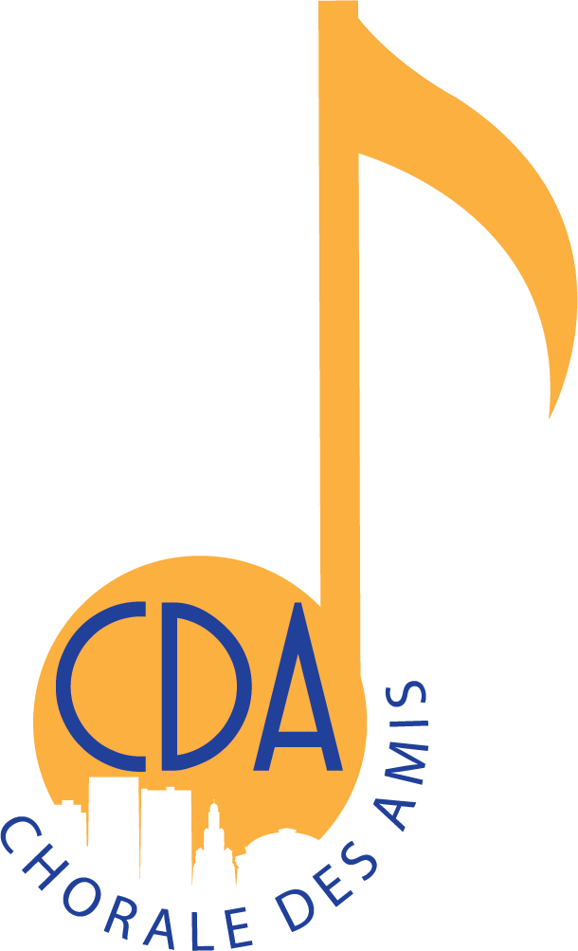

IMPORTANT DEADLINES

- September 10 by 5 pm – Deadline for online audition (All auditions are ONLINE!)
- September 12 – Postmark deadline for audition payments
- September 14 – Audition judging September 16 – Results posted on laacda.org website

FINANCIAL COMMITMENT

- Audition fee $15 non-refundable Registration fee
- upon acceptance into a choir $75 non-refundable
covers music, guest clinician and accompanist, insurance, practice tracks and name badge)
- Transportation to/from New Orleans
- Hotel
- Meals, T-shirt, and CD/DVD recordings of concert (optional)

Each recording should contain three items: a spoken introduction and two singing requirements.
Singers may only audition on one voice part. Multiple submissions will result in disqualification.

CHILDREN’S CHOIR (4th-6th grade)
- Track 1: Spoken introduction: student must speak his/her name and grade level. Student must sing “My Country ‘Tis of Thee” (not “America the Beautiful”). This should be a cappella and sung wherever it is most comfortable in the singer’s vocal range. 2.
- Track 2: “The Rainbow” by David Childs/Walton Music WLG127, measures 9-24

YOUTH CHOIR (7th-9th grade)
- Track 1: Spoken introduction: student must speak his/her name, grade level, and voice part.
  - Scales: student must sing all scales using the starting pitch indicated for their voice part below.
  - Scales must be sung a cappella using solfege, numbers, or a neutral syllable. Recommended tempo for scales is quarter note = 66-80.
  - All students must sing two major scales, each one ascending and descending.
    - Sopranos: E above middle C; G above middle C
    - Altos: E above middle C; A below middle C
    - Tenors: G below middle C; E below middle C
    - Basses: D below middle C; B-flat below C3 (the C below middle C)
- 2. Track 2: “Circa Mea” by Mark Burrows/Walton Music WW1614, measures 16-41

WOMEN’S CHOIR (10th-12th grade)

- Track 1: Spoken introduction: student must speak her name, grade level, and voice part.
  - Scales: student must sing all scales using the starting pitch indicated for their voice part below. Scales must be sung a cappella using solfege, numbers, or a neutral syllable. Recommended tempo for scales is quarter note = 66-80.
  - Women must sing two scales, each one ascending and descending
  - Soprano I: E above middle C; G above middle C
  - Soprano II: E above middle C; A below middle C
  - Alto I: D above middle C; G below middle C
  - Alto II: D above middle C; F below middle C 2.
- Track 2: “Even When He Is Silent” by Kim André Arnesen/Walton Music WW1580, measure 30-end

MEN’S CHOIR (10th-12th grade)

- Track 1: Spoken introduction: student must speak his name, grade level, and voice part.
  - Scales: student must sing all scales using the starting pitch indicated for their voice part below. Scales must be sung a cappella using solfege, numbers, or a neutral syllable. Recommended tempo for scales is quarter note = 66-80.
  - Men must sing two scales, each one ascending and descending.
  - Tenor I: F below middle C; A below middle C
  - Tenor II: G below middle C; C below middle C
  - Bass I: E below middle C; A below C3 (the C below middle C)
  - Bass II: D below middle C; F below C3 (the C below middle C)

- Track 2: “If Ye Love Me” ed. Randall Hooper/Manuscript http://laacda.org/wp-content/uploads/2019/04/If-Ye-Love-Me.pdf Sing from beginning and take the 2nd ending (no repeat)

Chorale des Amis directors will prepare, record and upload member auditions

